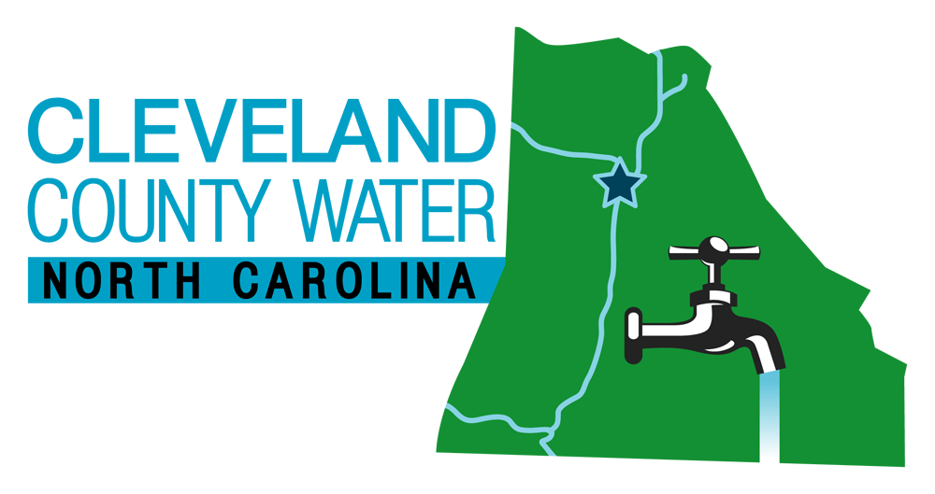
CLEVELAND COUNTY WATER
HYDRANT USAGE
AGREEMENT

PO BOX 8 TELEPHONE: 704-466-3696
SHELBY, NC 28151 FAX: 704-466-3245

The undersigned customer (hereinafter “Customer”) has requested from Cleveland County Water (hereinafter “CCW”) use of a hydrant belonging to the District for private residential purposes,

The water will be used for the following purpose(s): _________________________________________

Customer agrees to abide by all regulations imposed by CCW regarding use of a hydrant and the manner in which the water is taken from the hydrant.

Customer will be allowed to use a hydrant only if CCW gives prior written approval by signing this document. Customer will be allowed only to use a hydrant that is within reasonable proximity to the site for which water is needed (e.g.: swimming pool, holding tank). A properly connected fire hose in good repair will be required for the distribution of the water. The District shall not provide the hose but will ensure that the hose is properly connected. If in the sole discretion of the District, it is determined that the site of use is too far removed from the hydrant, Customer will be required to have a tanker go to the District’s water plant in order to obtain water. Absolutely no fill hose shall be laid across any roadways that will interrupt, impede, or impair vehicular traffic.
Under no circumstances shall a private individual be allowed to fill a tanker from a hydrant.
Service Address_______________________________________________

Customer shall pay to the District the following charges for water so used:
Contractor Deposit $1500.00
Service Call* $60.00
Rate See current Bulk Rate in Fee Schedule

Service Call fee does not apply if tanker is filled at the water plant.

Customer Name:__________________________________________
Mailing Address:_________________________________________
City, State, Zip:__________________________________________
Telephone:__________________________________________

I hereby agree to abide by all regulations of the District for water used from a hydrant or obtained at the water plant and pay the charges as stated herein.

____________________________________________ ____________
Customer Signature Date

____________________________________________ ____________ District Approval Date

Beginning reading________________ Meter Number_____________________________

Ending reading _________________

Total Gallons _________________

Maintenance Signature______________________________________ Date____________

